

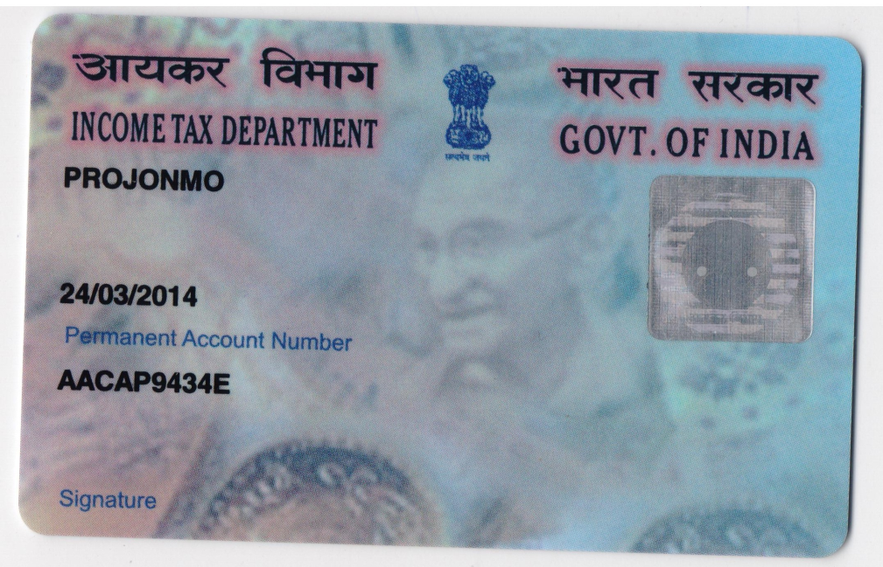

**PAN NO:** AACAP9434E

**BANK DETAILS:** Account Name: Projonmo

Bank: Bank of Baroda

Branch: Beltola Branch

Account No: 29650200000566

Acc. Type: Current Account

IFSC code: BARB0BELTOL